Report Lab 2:

Name: Nguyễn Trường Giang

StudentID: 20194751

Class: ICT 01 – K64

Exercise 1:

1. Show your path:

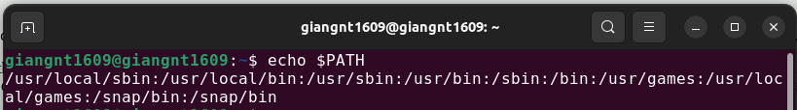2.

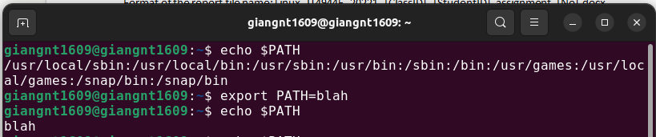The non-existing path “blah” will override the current path of the variable PATH in the system. After that, when we print the address of PATH is “blah”.

3.

-Path of home directory:

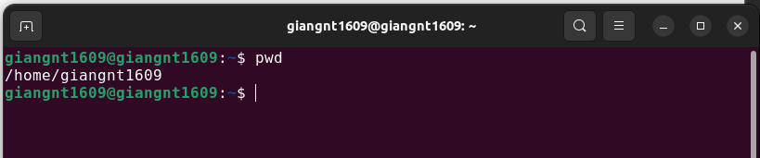- Other user can change their current directory by using command

cd /*home*/username if they have the permission to access on it.

4.

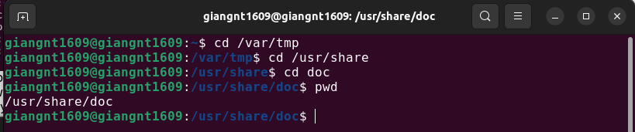

Exercise 2:

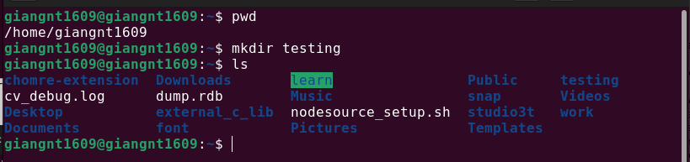1. Create a new directory in your home one

2. Move the new directory to the parent folder of your home directory

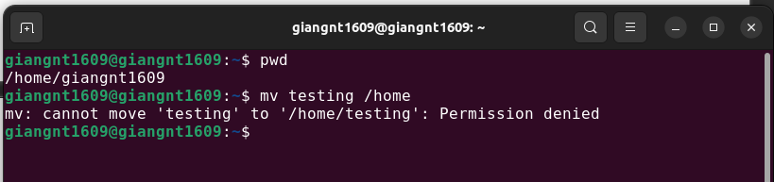Can’t move the directory for the parent folder because Permission denied. But if we add “sudo” to the command the could move it.

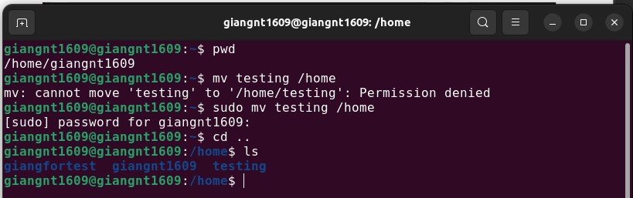

3. Copy all files PNG from /usr/share/pixmaps to your new created directory

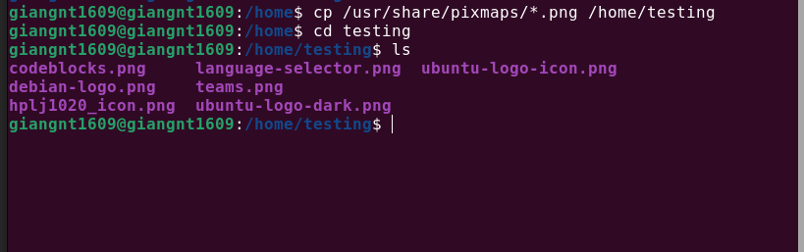4. List all copied files with the reverse alphabetical order.

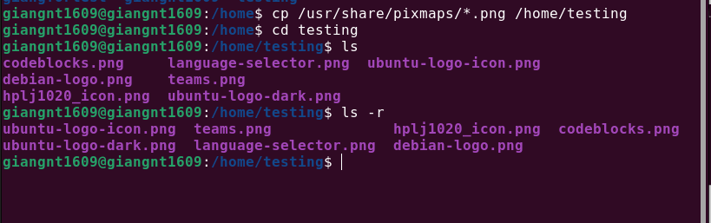

5. Switch to your home directory. Create a new directory and copy all files from /etc to your new directory.

We use “sudo” and option -a to get all the permission of coping all the file and directories.

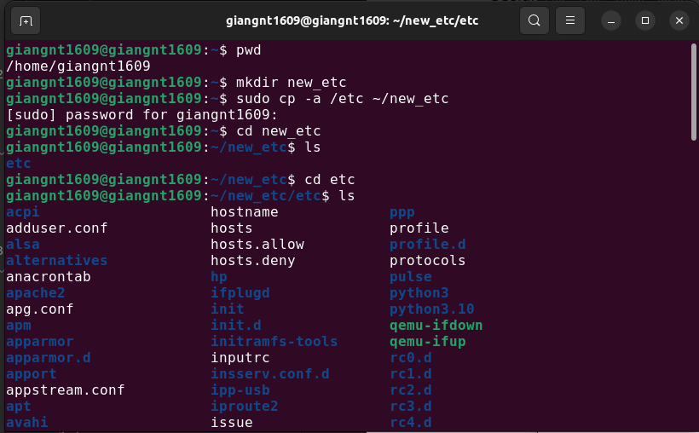6.

we create 2 folders:

“uppercase” for the files starting as a capitalized alphabetic character.

“lowercase” for the files starting as a non-capitalized alphabetic character.

We must use “sudo” code because in part 5 we copy with option “-a” (this option will make permission like the origin folder)

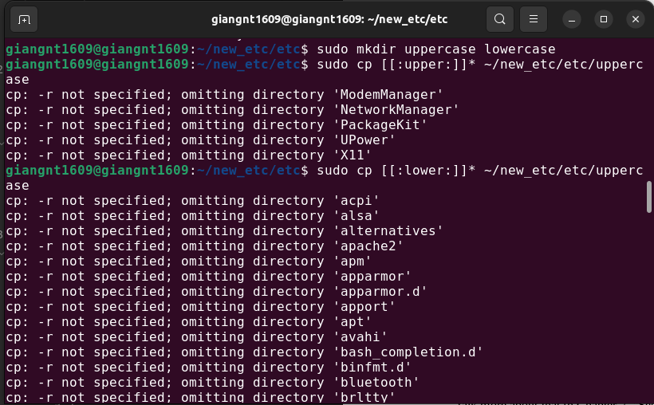( A part of coping the lowercase file and directories)

7. Delete the remaining files

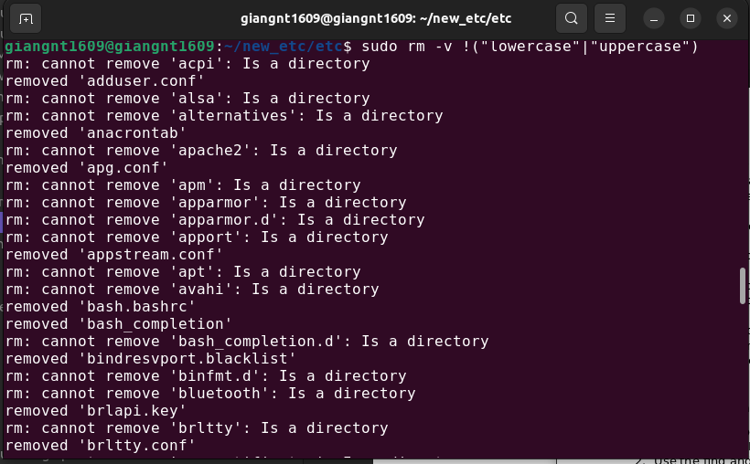we use sudo rm -v !(“lowercase”|”uppercase”) to remove all the file in directories and ignore the lowercase and uppercase.

8. Delete the whole new created folder and its content with a single command

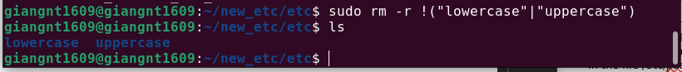

we use rm command with option -r and add !(“lowercase”|”uppercase”) to ignore them from removing.

9.

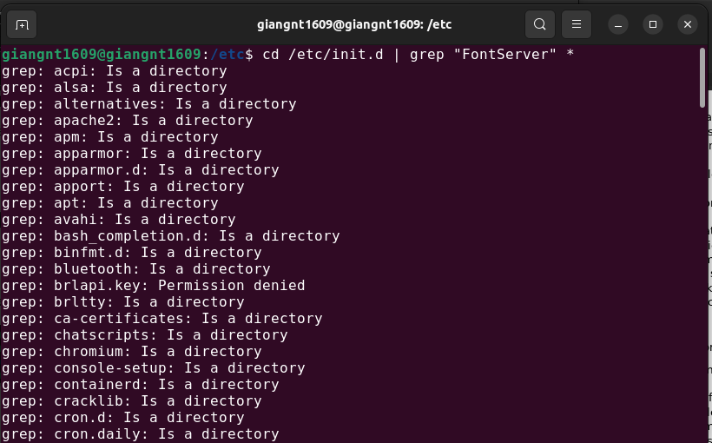

we change to init.d in /etc and grep “FontServer” form it.

10.

We can find the path of the program “semail” with 2 commands:

whereis semail (show all the path of them)

which -a semail (show all the path of them. If not have the option -a, the output will be return the default path of the program).

11.

we create symbolic link using command

and in the home directory we have tmp link.

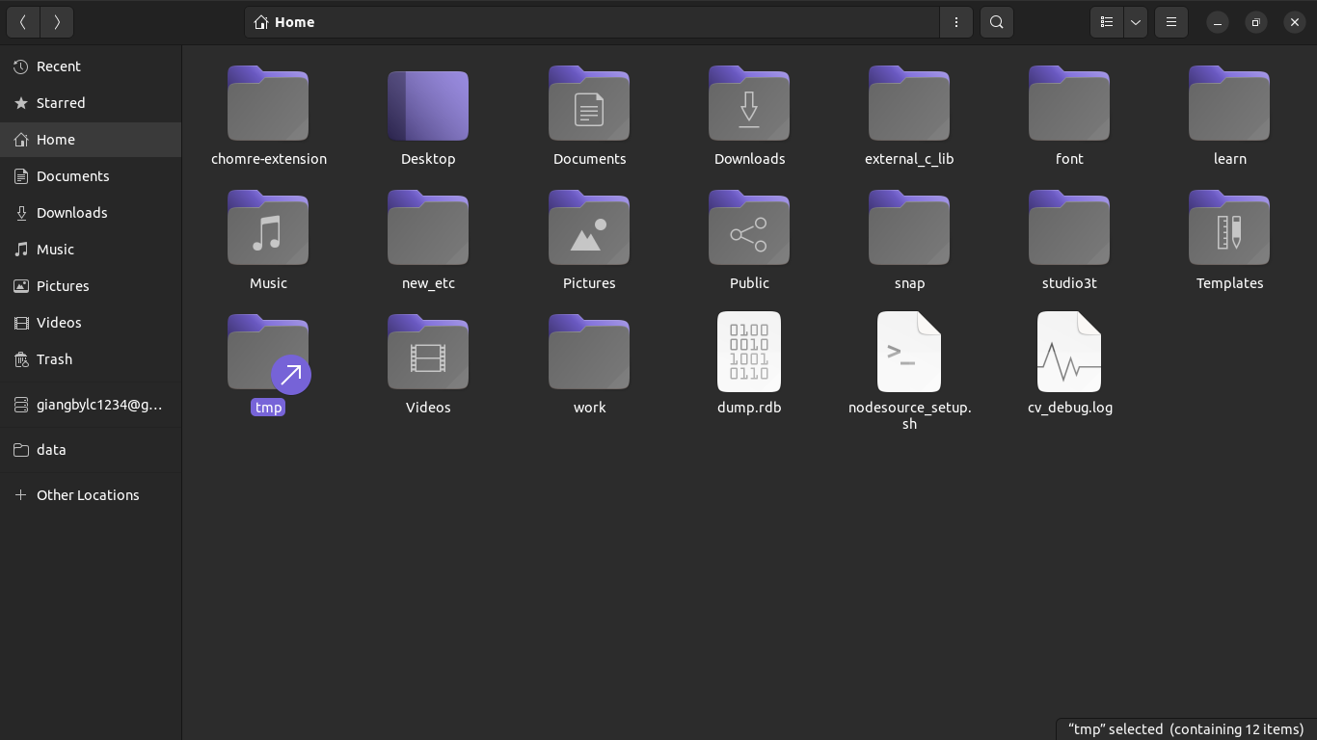12.

When we create a second link the output is an error because the file is exists.

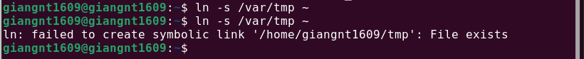So we need to remove that link and create a new one.

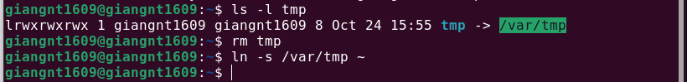

Exercise 3:

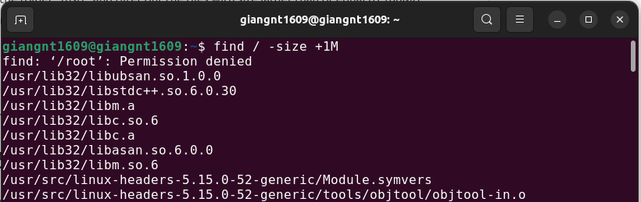1. We use the command “find” with the option “-size”.

( short output )

2.Use the find and file command to show all files inside /home (including sub directories and files).

+ The first way use: find \* /home

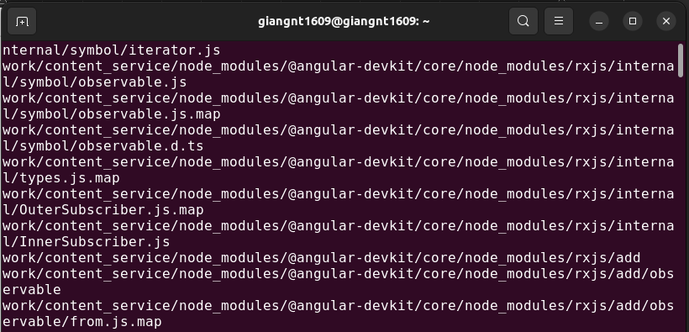( Short output )

+ The second way use: ls -R /home

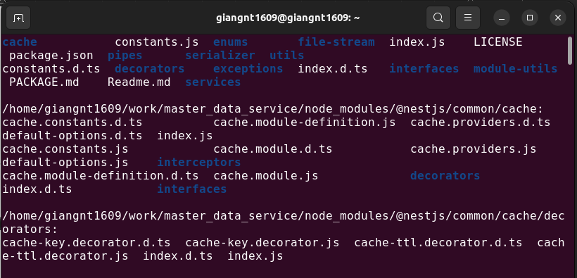( Short output )

3.Use the grep command to find the lines containing your username profile in the file /etc/passwd

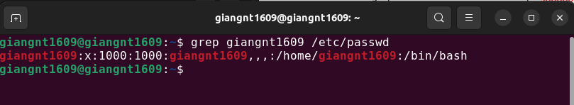

4. Use the command find, grep, and sort to list the sorted files containing the word “hello” in the file content of the /home directory (including sub-directories and files)

We use command: $sudo find /home | grep hello | sort.

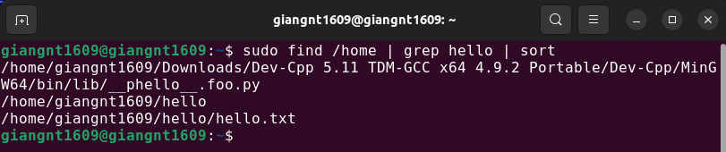5.

The command locate to find all file names containing the word “emacs”:

$find /home \* emacs\*

6

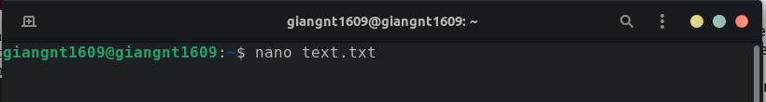Using nano command to create a file text.tx with content.

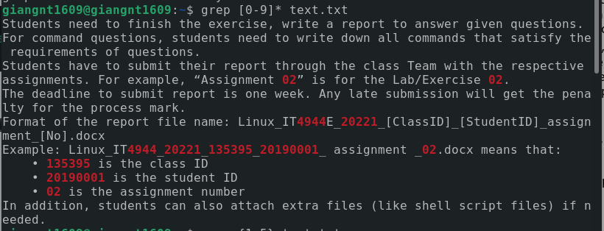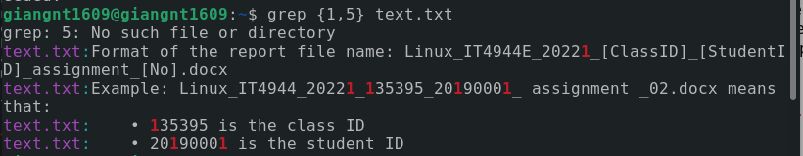Using each commands we got:

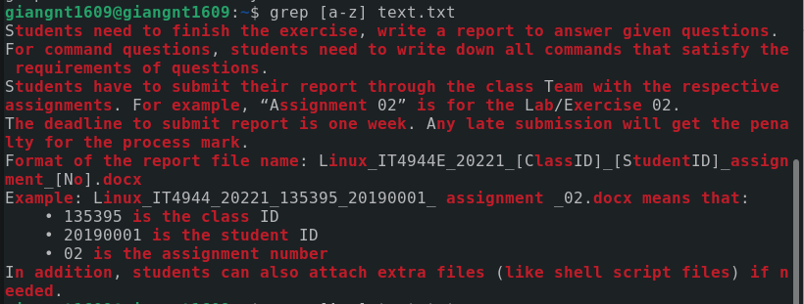

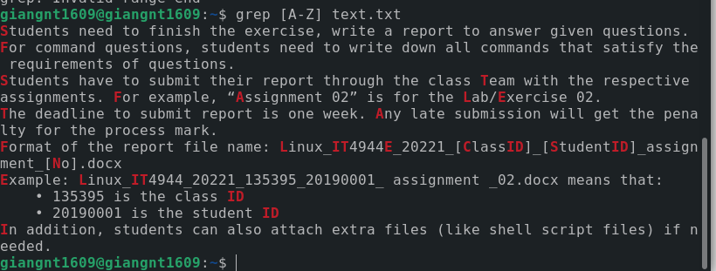

7. Because of the big size of /home so, we compress to another directory ~/hello

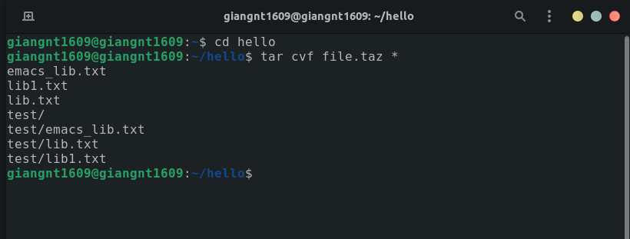

using tar command:

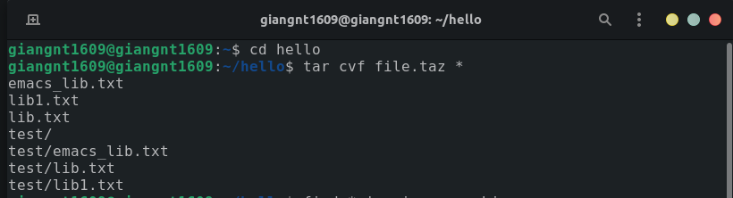

and using cpio command:

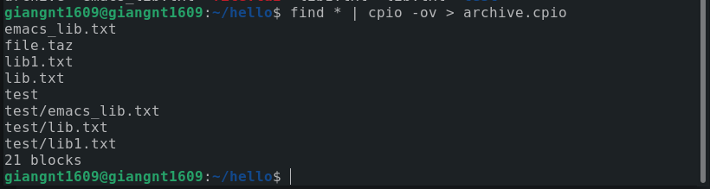after run 2 commands, we have 2 compressed file archive.cpio and file.taz



8.

Using commands: $od -A n -t d -N 1 /dev/urandom

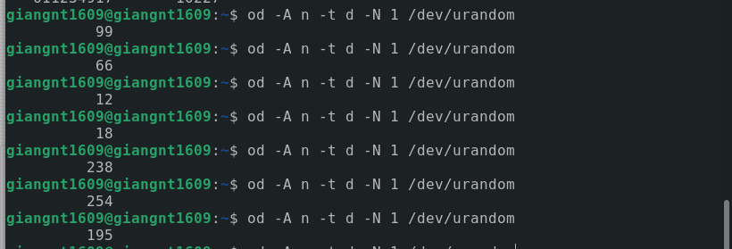9.

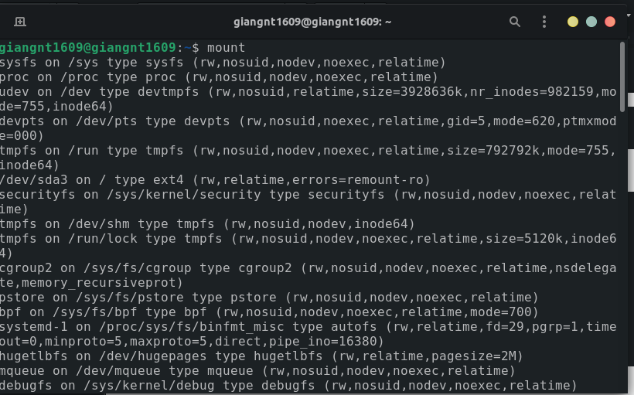The mount command will display the mount of filesystem of Ubuntu